Practical 5
Creating NEW Measures

A measure is a calculation that can be applied to any visual. We can use all aggregation operations like sum, average, min, and max to create measures using DAX (data analysis expressions). After creating a measure, it will not be saved in the dataset; it is simply a calculation, which will appear in "Fields" with the calculator symbol.

Steps to Create Calculated Measures
- Open Power BI Desktop and load the dataset.
- Navigate to the Home Menu, which can be found at the top left of the screen.
Now, on the right side of the home menu, under "Calculations," click "New Measure."
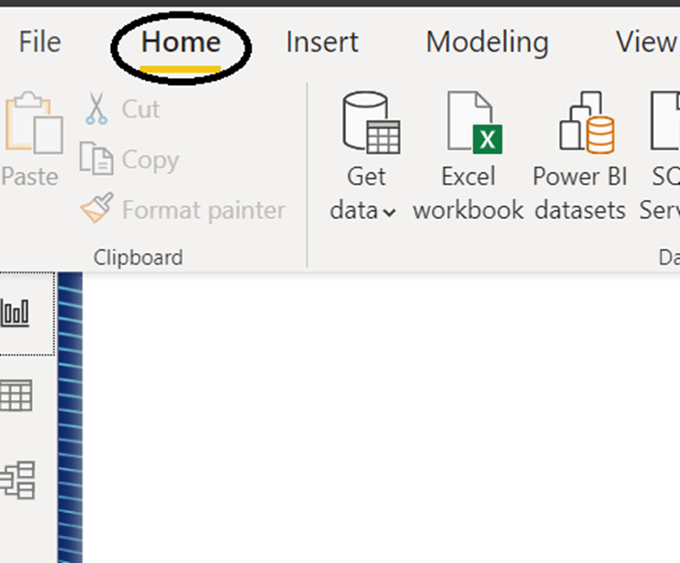
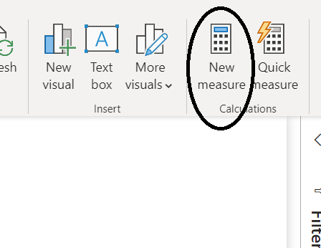
- After clicking on "New Measure," the formula bar is shown between the Menu and Report views.
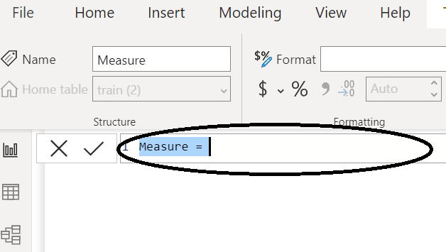
- Now let us rename the measure to our requirement, in this case, "AverageFare."
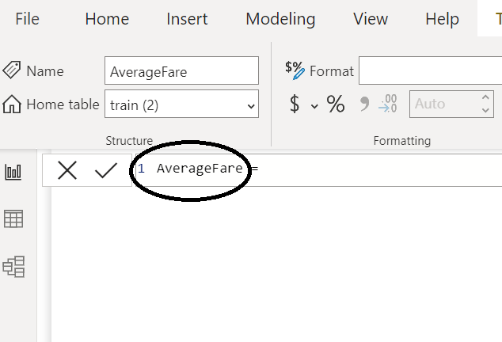

Measure name = Aggregation function('tablename'[column name])
In this case, we used the average function to determine the average ticket price.
- That's how simple it is. A measure is created, and we can find calculated measures in the "Fields" on the right side of the screen.
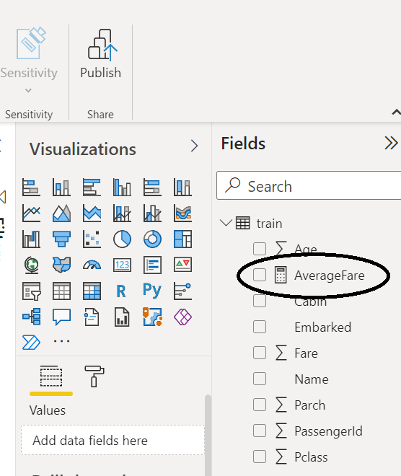
- Now it's time to visualize the calculated measure. To visualize, I am using this card visualization.
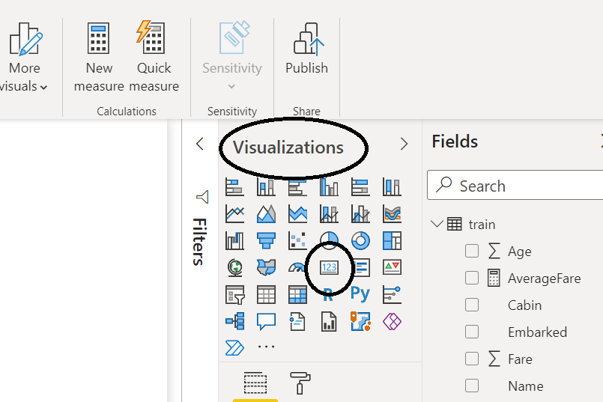
- After selecting, you can see an empty card on the report view.
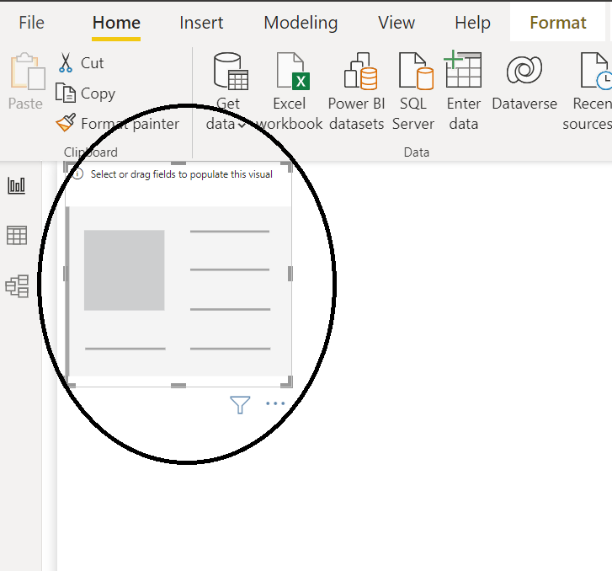
- Now select the check box next to the calculated measure, which is "AverageFare," in the Fields.

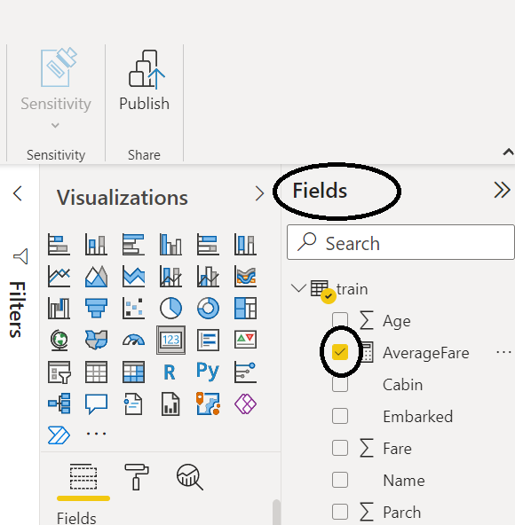

Now you can see the result.
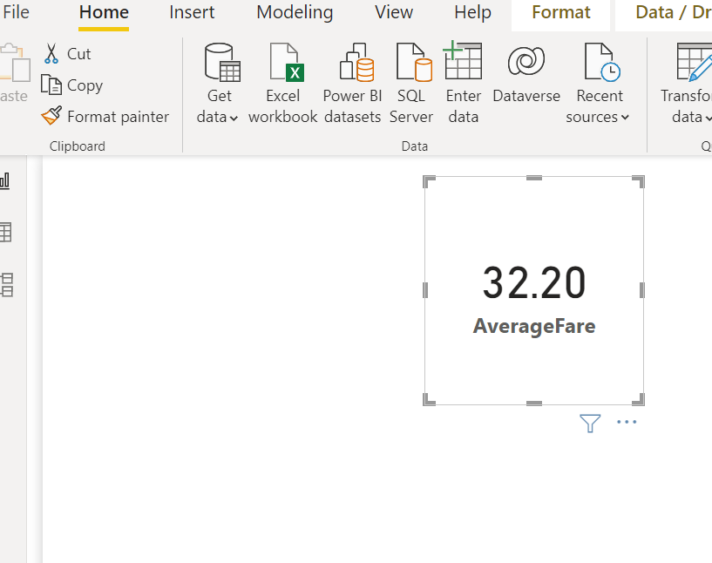

Steps to Create Quick Measures
Navigate to the Data pane and right-click a table or field, or use the Home ribbon.
Select New quick measure.
In the dialog box, select the Calculation from the dropdown menu.
Input the necessary fields into the dialog box.
Click OK.

